**The FIVE performance objectives:**

1. Quality (being right )
2. Speed (being fast in production)
3. Dependability ( delivery on time)
4. Flexibility ( ability to change )
5. Cost ( production costs )

*Quality :*

* All assemblies are to specification
* Product is reliable (won't break down when in use)
* Parts made to specification
* Product is attractive and blemish free

*Speed:*

* Time between customer request and delivery is minimized
* Time to deliver spare parts to service centers is minimized

*Dependability:*

* On time delivery to customer
* On time delivery of spare parts to service centers

*Flexibility:*

* Intro to new models
* Wide range of options
* Ability to adjust number of products produced
* Ability to reschedule manufacturing priorities

*cost:*

* Lowest cost possible of bought in material
* Lowest cost possible for staff
* Lowest cost possible for technology and facilities

**These parameters are also affected by the sequencing of the orders:**

**Types of sequences**: Due Date, first in first out, last come first served, longest operation time first, shortest operation time first.

**Advantages and disadvantages:**

Due date: simple, fast, performs well on dependability. High priority of past-due jobs, ignores the work content

FIFO: simple, fast, fair to the customer. Least effective a long job makes others wait, ignores due date and work remaining

Last in first out: orders in the bottom of the stack is delayed and work content is not considered

Longest operation time first: high utilization of machines. Lacks flexibility, ignores the due date

Shortest operation time first: simple, fast throughput time, low WIP. ignores downstream & due date & long jobs wait

Requirements:

* Maintain quality standards of the product
* Maintain machinery (maintenance & defects )
* Risk management

Tasks of our group:

* Provide a maintenance schedule based on the 5th page in the datasheet.
* ?

Planning:

Questions: what is meant by functional behavior, really vague on what to do, what is our final N2 diagram

1. • (Detail) analyses;
2. • Define the requirements for the sub-system;
3. • Describe the functions and the functional behavior;
4. • Design (or find) the required functional components and support your choices with calculations and/or simulations;
5. • Define the interfaces between components;
6. • Create an integration plan and a test plan;
7. • Use the result of the Statistic case to adapt the production system caused by the influence of variability on the production system;
8. • Present this in a research poster in English (final review).

**Systems engineering info:**

[**https://en.wikipedia.org/wiki/Systems_engineering**](https://en.wikipedia.org/wiki/Systems_engineering)

[**https://www.nasa.gov/seh/2-fundamentals**](https://www.nasa.gov/seh/2-fundamentals)

*• Quality, maintenance and risk management of the system*

**Risk management:** <https://nl.wikipedia.org/wiki/Risicobeheer>

<https://en.wikipedia.org/wiki/Risk_management>

Risk is the combination of end effect probability and severity (FMEA - wikipedia)

**Steps to analyze risk:** identify possible risks , quantify risks, determine impact of the risks on the development schedule ,research alternatives , let risks be part of the balance in decision making ,undertake actions (avoiding unnecessary risks, control risk (continue to monitor), take necessary risk (start early, make functional model,Test), transfer risk(put risk somewhere else like supplier or client, EULA, contract)  **(Risk analysis and handling)**

**Two aspects define risks:** probability of it happening and the consequences resulting from it happening. RISKf= Pf*Cf

**Risk analysis** (i think this part should be added to finance): **decision tree,** helps with making decisions with insight, choosing a design route that must be followed, analysis of different possible scenarios and design trajectories.

**Risk register,** keeps track of risks quantification, comparing to risk and strategy explicitly

**FMEA:**

<https://en.wikipedia.org/wiki/Failure_mode_and_effects_analysis#Example_of_FMEA_worksheet>

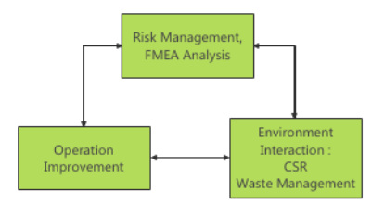

Catch up with system engineering AND production management lectures

**FMEA analysis:**

Description:

Failure Modes and Effects Analysis (FMEA) is a systematic, proactive method for evaluating a process to identify where and how it might fail and to assess the relative impact of different failures, in order to identify the parts of the process that are most in need of change[1].FMEA analysis is done depending on what is analyzed and we are focusing on the Process type which is an analysis of manufacturing and assembly processes. Both quality and reliability may be affected from process faults. The input for this FMEA is amongst others a work process / task breakdown[2].it is usually created within a spreadsheet, to help practitioners anticipate what might go wrong with a [product](https://www.isixsigma.com/dictionary/product/) or process. In addition to identifying how a product or process might fail and the effects of that failure, FMEA also helps find the possible causes of failures and the likelihood of failures being detected before occurrence.[3]

Used across many industries, FMEA is one of the best ways of analyzing potential reliability problems early in the development cycle, making it easier for manufacturers to take quick action and mitigate failure. The ability to anticipate issues early allows practitioners to design out failures and design in reliable, safe and [customer](https://www.isixsigma.com/dictionary/customer/)-pleasing features.[3]

How to approach and how would it look like:

First step is to identify all the components, systems, processes and functions that could potentially fail meeting the required level of quality or reliability.

We have 3 categories that have different measurements and then these measurements are multiplied to each other to get us a total value that help us have a sense on which risk is the priority and what to prioritize over what

The first category consists of, **potential failure effects;** which describes what is the impact on the customer if failure mode is not prevented, The **SEV number;** indicates how severe the effect is on customers.

The second category consists of **potential causes;** which discusses the causes for the failure mode to occur (what causes the step to go wrong) **, OCC;** which indicateshow frequent the cause that leads to failure occurs

The third category consists of  **current process controls;** discusses the existing measures taken to prevent the cause that leads to the step failing or detect it before it even occurs **, DET;** indicates how probable it is to detect the failure mode before it occurs or detect the cause which leads to it failing

After getting all 3 numbers we multiply them all together to get the **RPN number; indicates the risk priority number which shows where are the process’s greatest risk**

This is an example FMEA analysis

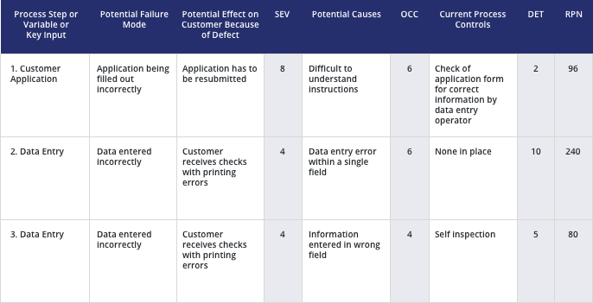

After initial analysis and after figuring out where in our process the highest risk. Decisions are then made to minimize that risk. After that we are going to do another FMEA analysis when the improvements are implemented to see how much the RPN number of the process of interest has reduced within the desired range or still needs to be reduced further, Basically comparing the old with the new

This how the final analysis should look like ( where the initial analysis is from column 1 to 9 and the second one is from column 10 to 16)

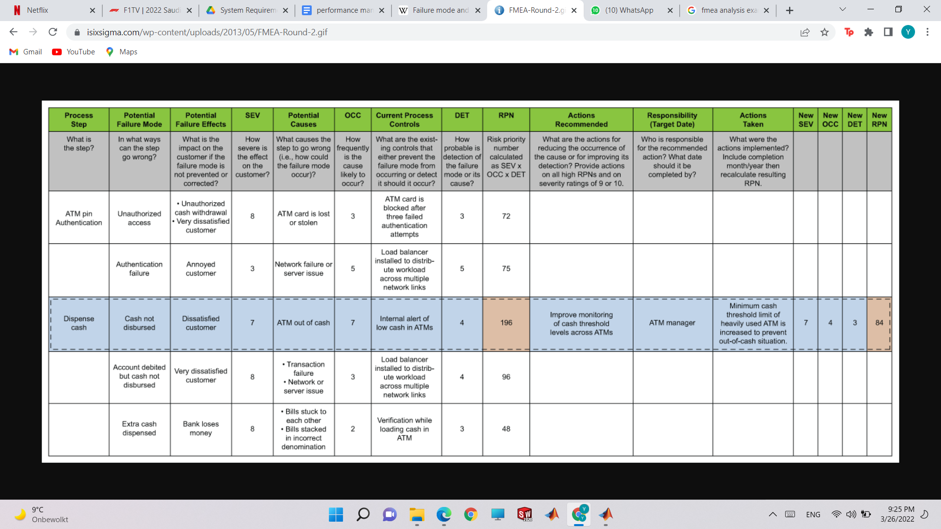

OUR FOCUS POINTS:

Since our top priority is quality and dependability for our performance parameters we are going to treat any delays in manufacturing time or any drop of quality in any product done as risk parameters and we are also gonna consider speed and cost but they are less prioritized than the first two.

**Plan:**

**Step 1:** brainstorm potential failure effects for parts in the system that may cause delay in manufacturing or drop of quality and how it will impact customers. After doing that as a group assume an SEV number for the effect on a scale of 1 to 10 with ten being extremely affected.

**Step 2:** brainstorm potential causes for those potential failure and how frequent they might be caused using sensible arguments and data and then assume an OCC number

**Step 3:** check if there is anything in your system that might prevent a failure or the cause of failure to occur or can detect it before it occurs then assume a DET number which is how probable are these to detect or prevent failure or a cause of one.

Things we might need:

Layout of system

Spec sheet of the machines

data from the past to have more realistic assumptions

Process times

Delays

Etc